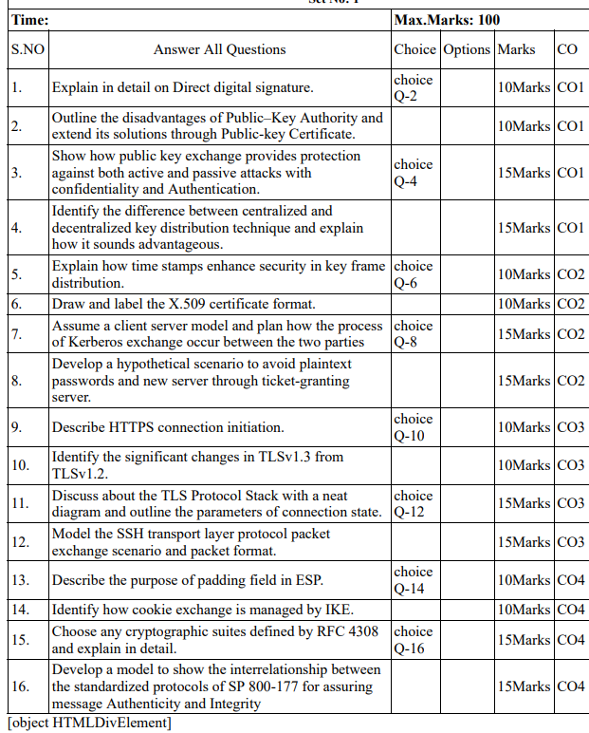

**1.**The Direct Digital Signature is only included two parties one to send a message and the other one to receive it. According to the direct digital signature both parties trust each other and know their public key. The message is prone to get corrupted and the sender can decline the message sent by him at any time.

**Advantages:**

Simplicity: Direct digital signatures are simple and straightforward to implement, requiring only the use of digital certificates and a secure private key.

Speed: Direct digital signatures are fast and efficient, allowing for quick signing of electronic documents.

Security: Direct digital signatures are secured using strong cryptographic techniques, making it difficult for unauthorized parties to access or alter the signature.

**Disadvantages:**

Limited scope: Direct digital signatures can only be used for documents that are exchanged between two parties, making it less suitable for situations that require multiple signatures.

Lack of impartiality: Direct digital signatures may be seen as less impartial than arbitrated digital signatures, as they do not require a third-party to verify the identity of the signer.

Requirements for a digital signature:

· Must authenticate the content of the message at the time of the signature

· Must authenticate the author, date, and time of the signature

· Receiver can verify the claimed identity of the sender

· Sender cannot later repudiate the content of the message

· Receiver cannot possibly have concocted the message himself

· Can be verified by third-parties to resolve disputes

Examples:

· The bank needs to verify the identity of the client placing a transfer order

· The client cannot deny later having sent that order

· It is impossible for the bank to create transfer orders and claim they actually came from the client

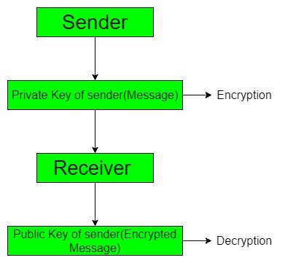

**2.** It seems there might be a slight confusion in the terminology. Public-Key Authority is not a standard term in the context of cryptography or security. However, I assume you are referring to the disadvantages of using a public-key infrastructure (PKI) and how public-key certificates can address some of these challenges.

**Disadvantages of Public-Key Infrastructure (PKI):**

1. **Trust and Certificate Authority (CA) Dependency:**
   * *Issue:* PKI relies on a centralized Certificate Authority (CA) for issuing and managing digital certificates. Trust in the system depends heavily on the trustworthiness of the CA.
   * *Solution:* Enhance the security and trustworthiness of CAs, or consider decentralized alternatives like blockchain-based PKIs.
2. **Certificate Revocation Challenges:**
   * *Issue:* Revoking compromised or expired certificates can be a cumbersome process. CRLs (Certificate Revocation Lists) can be inefficient and may not be checked in real-time.
   * *Solution:* Implement Online Certificate Status Protocol (OCSP) for real-time certificate revocation checks or explore emerging technologies like Certificate Transparency.
3. **Key Management Complexity:**
   * *Issue:* Managing and securing private keys can be complex, especially in large-scale deployments. If a private key is compromised, it can lead to serious security breaches.
   * *Solution:* Use Hardware Security Modules (HSMs) for secure key storage and management. Implement key rotation policies and use secure key generation practices.
4. **Scalability Issues:**
   * *Issue:* As the number of users and devices increases, managing a large-scale PKI can become challenging.
   * *Solution:* Implement hierarchical PKI structures, distribute responsibilities among multiple CAs, and use efficient key distribution mechanisms.
5. **Lack of Interoperability:**
   * *Issue:* Different applications and systems may have varying support for PKI standards, leading to interoperability challenges.
   * *Solution:* Ensure adherence to widely accepted PKI standards like X.509 and use well-established cryptographic algorithms to enhance interoperability.

**Public-Key Certificates as a Solution:**

1. **Authentication and Trust:**
   * *Solution:* Public-key certificates provide a way to authenticate the identity of the certificate holder, establishing trust without relying solely on the CA. Use of extended validation certificates can enhance trust levels.
2. **Efficient Revocation:**
   * *Solution:* Public-key certificates can incorporate information about revocation status, and technologies like OCSP can be used to check the status in real-time, addressing the challenges associated with CRLs.
3. **Simplified Key Distribution:**
   * *Solution:* Certificates contain public keys and can be distributed securely, simplifying the process of sharing public keys among users and devices.
4. **Enhanced Security:**
   * *Solution:* By implementing secure key management practices and using technologies like HSMs, the security of private keys associated with certificates can be significantly improved.
5. **Standardization and Interoperability:**
   * *Solution:* Public-key certificates adhere to widely accepted standards, promoting interoperability across different systems and applications.

It's important to note that while public-key certificates address some of the challenges associated with PKI, their effective implementation also requires careful consideration of specific use cases, security policies, and ongoing management practices.

**3.** Public key exchange, often employed in public key cryptography, provides protection against both active and passive attacks while ensuring confidentiality and authentication. Let's explore how this is achieved:

**1. Confidentiality:**

**Passive Attack (Eavesdropping):**

* **Scenario:**
  + Alice wants to send a confidential message to Bob.
  + Eve, an eavesdropper, intercepts the communication between Alice and Bob.
* **Solution using Public Key Exchange (Asymmetric Cryptography):**
  + **Key Pair Generation:**
    - Bob generates a public-private key pair.
  + **Public Key Distribution:**
    - Bob shares his public key openly.
  + **Message Encryption:**
    - Alice uses Bob's public key to encrypt the message.
  + **Message Decryption:**
    - Bob, with his private key, decrypts the received message.
* **Result:**
  + Even if Eve intercepts the encrypted message, she cannot decrypt it without Bob's private key.

**Active Attack (Man-in-the-Middle):**

* **Scenario:**
  + Eve intercepts the communication between Alice and Bob and alters the message.
* **Solution:**
  + **Digital Signatures:**
    - Alice signs her message with her private key.
  + **Public Key Verification:**
    - Bob uses Alice's public key to verify the signature.
* **Result:**
  + Even if Eve alters the message, Bob can detect it because the signature won't match.

**2. Authentication:**

**Passive Attack (Identity Spoofing):**

* **Scenario:**
  + Bob wants to verify that a message is genuinely from Alice.
* **Solution:**
  + **Digital Signatures:**
    - Alice signs her message with her private key.
  + **Public Key Verification:**
    - Bob uses Alice's public key to verify the signature.
* **Result:**
  + Bob can be confident that the message is from Alice because only Alice possesses the private key corresponding to the public key used for verification.

**Active Attack (Impersonation):**

* **Scenario:**
  + Eve tries to impersonate Alice.
* **Solution:**
  + **Digital Signatures:**
    - Alice signs her messages with her private key.
  + **Public Key Verification:**
    - Bob uses Alice's public key to verify the signature.
* **Result:**
  + Even if Eve alters the message, Bob can detect the impersonation because Eve doesn't have Alice's private key to create a valid signature.

In summary, public key exchange addresses both passive and active attacks:

* **Passive Attacks:**
  + Public key encryption prevents eavesdroppers from understanding the content.
  + Digital signatures ensure the integrity of the message.
* **Active Attacks:**
  + Digital signatures protect against message alteration and impersonation.

Public key exchange, through the use of asymmetric cryptography, provides a robust mechanism for securing communication channels, ensuring confidentiality through encryption and authentication through digital signatures.

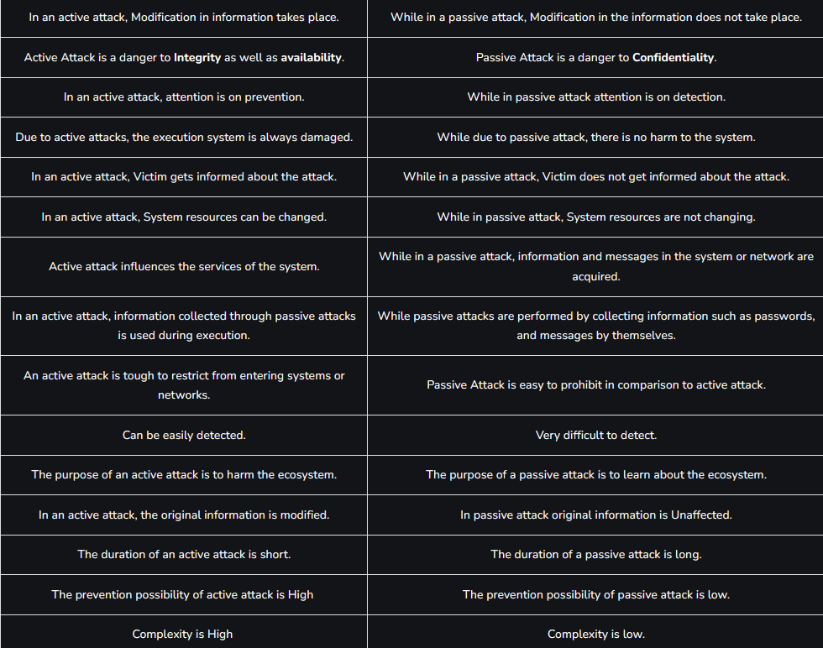

**4. Centralized Key Distribution:**

In a centralized key distribution system, a single authority or entity is responsible for generating, managing, and distributing cryptographic keys to all entities in the system. This central authority is typically a Key Distribution Center (KDC) or a centralized server.

**Advantages of Centralized Key Distribution:**

1. **Simplicity and Efficiency:**
   * *Advantage:* Centralized systems are often simpler to implement and manage. The central authority can efficiently distribute keys to all participants.
2. **Centralized Security Control:**
   * *Advantage:* Security policies and controls can be centrally enforced and monitored, making it easier to ensure compliance and respond to security incidents.
3. **Key Revocation:**
   * *Advantage:* If a key needs to be revoked, the central authority can easily update its records and inform all participants about the revocation.
4. **Resource Optimization:**
   * *Advantage:* Centralized systems may be more resource-efficient as they can optimize key distribution processes and utilize centralized resources.

**Decentralized Key Distribution:**

In a decentralized key distribution system, there is no single central authority responsible for all key management. Instead, different entities or nodes in the network may have their own key management capabilities, and keys are distributed among them.

**Advantages of Decentralized Key Distribution:**

1. **Resilience and Redundancy:**
   * *Advantage:* Decentralized systems can be more resilient to failures and attacks. If one node is compromised, it doesn't compromise the entire system.
2. **Scalability:**
   * *Advantage:* Decentralized systems can be more scalable as the key distribution load is distributed across multiple entities. This is particularly advantageous in large-scale networks.
3. **Flexibility and Autonomy:**
   * *Advantage:* Participants in a decentralized system may have more autonomy and flexibility in managing their own keys without relying on a central authority.
4. **Security in Depth:**
   * *Advantage:* Even if one part of the network is compromised, the impact may be limited to that specific segment, and other parts of the network can remain secure.

**Overall Considerations:**

* **Security Trade-offs:**
  + Centralized systems may be more straightforward to secure, but they present a single point of failure. Decentralized systems distribute the risk but may require more sophisticated security measures.
* **Use Case Dependency:**
  + The choice between centralized and decentralized key distribution depends on the specific use case, the size of the network, and the desired balance between simplicity and resilience.
* **Hybrid Approaches:**
  + In some scenarios, hybrid approaches that combine centralized and decentralized elements are used to leverage the benefits of both models.

In conclusion, the choice between centralized and decentralized key distribution depends on the specific requirements and considerations of the system in question. Each approach has its advantages, and the selection should be based on factors such as security, scalability, and operational efficiency.

**5.** In the context of key frame distribution, timestamps play a crucial role in enhancing security by providing a mechanism to manage and validate the temporal order of key frames. Key frames are essential in video compression and transmission, serving as reference points for decoding subsequent frames. Here's how timestamps contribute to security in key frame distribution:

1. **Ordering and Synchronization:**
   * **Issue:** In a video stream, key frames must be transmitted and received in the correct order for proper decoding.
   * **Solution:** Timestamps associated with key frames indicate their temporal order. Receivers can use timestamps to reconstruct the correct sequence of key frames, ensuring synchronization during playback.
2. **Preventing Replay Attacks:**
   * **Issue:** Without proper safeguards, an attacker might intercept and replay key frames, attempting to disrupt the sequence or introduce malicious content.
   * **Solution:** Timestamps provide a mechanism to detect and reject replayed key frames. Receivers can compare the timestamp of incoming key frames with the expected timeline, rejecting frames that fall outside an acceptable time window.
3. **Temporal Integrity Verification:**
   * **Issue:** Tampering with key frames could compromise the integrity of the video stream.
   * **Solution:** Timestamps serve as a form of integrity verification. If a key frame arrives with a timestamp that does not align with the expected temporal progression, it could indicate tampering, and the frame can be treated as suspicious.
4. **Mitigating Delay and Jitter:**
   * **Issue:** Network delays or jitter may cause variations in the arrival time of key frames.
   * **Solution:** Timestamps help receivers account for delays and jitter by providing a reference point. Timestamp information can be used to manage the reordering of frames based on their arrival times, ensuring proper decoding and playback.
5. **Enabling Timely Key Updates:**
   * **Issue:** Periodic updating of key frames is essential for security, especially in scenarios where key frames are used for encryption.
   * **Solution:** Timestamps aid in scheduling and managing the timely distribution of key frames. Systems can use timestamps to trigger the generation and distribution of new key frames at predetermined intervals, enhancing the security of the video stream.
6. **Synchronization with External Systems:**
   * **Issue:** In scenarios where video streams need to be synchronized with other external systems or events, temporal alignment is crucial.
   * **Solution:** Timestamps facilitate synchronization by providing a common time reference. This is particularly important in applications where multiple streams or data sources need to be aligned.

In summary, timestamps in key frame distribution enhance security by ensuring the correct temporal order of frames, preventing replay attacks, verifying temporal integrity, mitigating delays, enabling timely key updates, and facilitating synchronization with external systems. They play a critical role in maintaining the integrity and security of video streams in a dynamic and potentially adversarial network environment.

**6.** 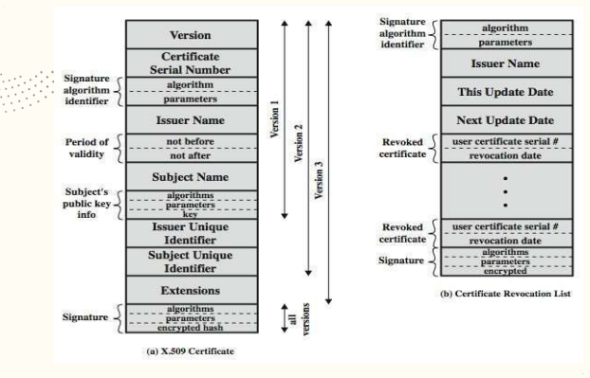

NIS c02-===pg=43

Recommendation of ITU-D and series of X.500.   
¬ X.509 defines a framework for the provision of authentication services by the X.500 directory to its users.   
¬ Each certificate contains the public key of a user and is signed with the private key of a trusted certification authority.   
¬ X.509 defines alternative authentication protocols based on the use of public-key certificates.  
 ¬ X.509 certificate format is used in S/MIME.   
¬ X.509 is based on the use of public-key cryptography and digital signatures.  
**Elements of X.509 Certificate** θ version V (1, 2, or 3)   
θ serial number SN (unique within CA) identifying certificate   
θ signature algorithm identifier AI θ issuer X.500 name CA)   
θ period of validity TA (from - to dates)   
θ subject X.500 name A (name of owner)   
θ subject public-key info Ap (algorithm, parameters, key)   
θ issuer unique identifier (v2+)   
θ subject unique identifier (v2+)   
θ extension fields (v3)   
θ signature (of hash of all fields in certificate)   
¬ Notation CA<> denotes certificate for A signed by C

**7.** CO2 ==86ppt

The Kerberos authentication protocol is commonly used in a client-server model to enable secure authentication without transmitting plaintext passwords over the network. Here's a step-by-step process of how the Kerberos exchange occurs between the client and server:

**1. Initial Request:**

* The client sends a request to the Authentication Server (AS) for a Ticket Granting Ticket (TGT).
* The request includes the client's identity (username).

**2. Ticket Granting Ticket (TGT) Request:**

* The AS generates a TGT for the client and encrypts it with the client's password (or a key derived from the password).
* The TGT is sent back to the client.

**3. TGT Request to Ticket Granting Server (TGS):**

* The client wants to access a specific service, so it sends the TGT to the Ticket Granting Server (TGS) along with the requested service identifier (service name).

**4. Service Ticket Generation:**

* The TGS decrypts the TGT using the client's password, verifying the client's identity.
* If the client is authenticated, the TGS generates a Service Ticket for the requested service and encrypts it using the service's secret key.
* The Service Ticket, along with the client's identity and a session key, is sent back to the client.

**5. Service Request:**

* The client sends the Service Ticket to the server along with the client's identity.

**6. Service Ticket Validation:**

* The server uses its secret key to decrypt the Service Ticket.
* If the decryption is successful, the server knows the client is authenticated.
* The server extracts the session key and generates a response encrypted with the session key.

**7. Client Authentication:**

* The client decrypts the server's response using the session key.
* If successful, the client and server are mutually authenticated, and a secure session is established.

**8. Subsequent Requests:**

* For subsequent requests to the same service, the client and server use the established session key for secure communication without re-authenticating.

**8.Co2 56ppt version-4**

**9.** co3 materila 33 best

HTTPS (HTTP over SSL) refers to the combination of HTTP and SSL to implement secure communication between a Web browser and a Web server. The HTTPS capability is built into all modern Web browsers.   
When HTTPS is used, the following elements of the communication are encrypted: • URL of the requested document • Contents of the document • Contents of browser forms (filled in by browser user) • Cookies sent from browser to server and from server to browser • Contents of HTTP header.  
**HTTPS-Connection Initiation**   
• For HTTPS, the agent acting as the HTTP client also acts as the TLS client. • The client initiates a connection to the server on the appropriate port and then sends the TLS ClientHello to begin the TLS handshake. • When the TLS handshake has finished, the client may then initiate the first HTTP request. • All HTTP data is to be sent as TLS application data. Normal HTTP behavior, including retained connections, should be followed.

There are three levels of awareness of a connection in HTTPS. • At the HTTP level, an HTTP client requests a connection to an HTTP server by sending a connection request to the next lowest layer. • Typically, the next lowest layer is TCP, but it also may be TLS/SSL. At the level of TLS, a session is established between a TLS client and a TLS server. • This session can support one or more connections at any time. • As we have seen, a TLS request to establish a connection begins with the establishment of a TCP connection between the TCP entity on the client side and the TCP entity on the server side.

• An HTTP client or server can indicate the closing of a connection by including the following line in an HTTP record: • Connection: close. • This indicates that the connection will be closed after this record is delivered. • A TLS implementation may, after sending a closure alert, close the connection without waiting for the peer to send its closure alert, generating an “incomplete close”.

**10.**

TLS (Transport Layer Security) is a protocol that ensures privacy between communicating applications and users on the Internet. TLS versions evolve to address vulnerabilities, improve security, and enhance performance. TLS 1.3 is the latest version, and it introduced several significant changes compared to TLS 1.2. Here are some key differences:

1. **Handshake Process:**
   * *TLS 1.2:* The handshake process involves multiple round trips between the client and server to negotiate cryptographic parameters, which can introduce latency.
   * *TLS 1.3:* The handshake process is more efficient, reducing the number of round trips required for negotiation. This helps improve the speed of establishing a secure connection.
2. **Forward Secrecy:**
   * *TLS 1.2:* Forward secrecy (the property that ensures that a compromise of the server's private key does not compromise past session keys) relies on the key exchange algorithm used (such as DHE or ECDHE).
   * *TLS 1.3:* Forward secrecy is enforced by design. All key exchange methods in TLS 1.3 provide forward secrecy, making it a default and mandatory feature.
3. **Key Exchange Algorithms:**
   * *TLS 1.2:* RSA key exchange and key exchange mechanisms based on static Diffie-Hellman are commonly used.
   * *TLS 1.3:* RSA key exchange is deprecated, and only key exchange mechanisms providing forward secrecy are supported. This includes Elliptic Curve Diffie-Hellman (ECDHE) and finite field Diffie-Hellman (DHE).
4. **Removed Legacy Cryptographic Algorithms:**
   * *TLS 1.3:* Several legacy cryptographic algorithms and features have been removed for improved security. This includes MD5, SHA-224, DES, 3DES, static RSA key exchange, and non-AEAD (Authenticated Encryption with Associated Data) ciphers.
5. **Improved Security and Resilience:**
   * *TLS 1.3:* The protocol is designed with a focus on improved security, removing known vulnerabilities and addressing weaknesses present in TLS 1.2. It also minimizes the attack surface and mitigates certain types of attacks.
6. **0-RTT (Zero Round-Trip Time Resumption):**
   * *TLS 1.3:* Introduces a 0-RTT mode, allowing clients and servers to resume a previous session without performing a full handshake, reducing latency for subsequent connections.
7. **Simplified Cipher Suites:**
   * *TLS 1.3:* The number of supported cipher suites is significantly reduced for simplicity and to eliminate less secure options.
8. **Encrypted Handshake Messages:**
   * *TLS 1.3:* Handshake messages are encrypted, providing additional confidentiality and preventing certain types of attacks that exploit unprotected handshake messages.
9. **Session Resumption:**
   * *TLS 1.3:* The session resumption mechanism is simplified, and the use of session IDs is deprecated in favor of the new session ticket mechanism.
10. **Removed Compression:**
    * *TLS 1.3:* Compression is completely removed, as it was susceptible to the CRIME attack. Compression at the TLS level is no longer supported.

Overall, TLS 1.3 represents a significant improvement over TLS 1.2 in terms of security, efficiency, and performance. It introduces changes to the handshake process, key exchange algorithms, and the removal of legacy features to enhance the overall security of the protocol.

**Ppt 52 add some text side headings**

The TLS (Transport Layer Security) protocol stack is designed to provide secure communication over a network. It operates as a protocol suite layered on top of the transport layer (typically using TCP). Below is a simplified diagram of the TLS protocol stack:

**+----------------------------------+**

**| Application Layer (e.g., HTTP)|**

**+----------------------------------+**

**| TLS Record Layer |**

**+----------------------------------+**

**| TLS Handshake Layer |**

**+----------------------------------+**

**| TLS Change Cipher Spec |**

**+----------------------------------+**

**| TLS Alert Protocol |**

**+----------------------------------+**

**| TLS Application Data |**

**+----------------------------------+**

**| Transport Layer |**

**+----------------------------------+**

**| Network Layer |**

**+----------------------------------+Explanation of Layers:**

1. **Application Layer:**
   * The highest layer where the actual application data resides (e.g., HTTP, SMTP). TLS operates beneath this layer, securing the data in transit.
2. **TLS Record Layer:**
   * Responsible for breaking the application data into manageable fragments.
   * Performs compression (though compression is typically disabled due to security concerns in modern implementations).
   * Applies encryption and integrity protection.
3. **TLS Handshake Layer:**
   * Manages the negotiation and establishment of a secure connection between the client and server.
   * Exchange of cryptographic parameters and the generation of shared keys occur at this layer.
4. **TLS Change Cipher Spec:**
   * Signifies the end of the handshake phase and the beginning of secured communication.
   * The Change Cipher Spec Protocol is a single message that indicates that subsequent communication will be encrypted.
5. **TLS Alert Protocol:**
   * Handles notification of errors or issues during the TLS connection.
   * Alerts can be warnings or fatal errors.
6. **TLS Application Data:**
   * The layer where encrypted application data is transmitted securely.

**Parameters of Connection State:**

The connection state in TLS is maintained on both the client and server sides and includes various parameters negotiated during the handshake. Key connection state parameters include:

1. **Session ID:**
   * An identifier for a specific session. Can be used for session resumption.
2. **Cipher Suite:**
   * Specifies the encryption and hash algorithms used for communication.
3. **Compression Method:**
   * Specifies the compression algorithm used (though compression is typically disabled).
4. **Master Secret:**
   * A shared secret generated during the handshake that is used to derive encryption keys.
5. **Pre-Master Secret:**
   * A secret exchanged during the key exchange process, contributing to the generation of the master secret.
6. **Random Values:**
   * Random values generated during the handshake process, used in the key derivation process.
7. **Sequence Numbers:**
   * Used to protect against replay attacks by assigning a unique sequence number to each record.
8. **Cipher State:**
   * The current encryption state, including the encryption and MAC keys.
9. **Compression State:**
   * The current state of compression, even though modern TLS versions generally do not use compression.

These parameters collectively define the security context of the TLS connection and are crucial for the establishment of a secure and confidential communication channel between the client and server.

**Alert Codes TLS** includes support for all the alert codes specified in SSLv3, except for "no_certificate." In addition to these, TLS introduces several new alert codes. Among the new codes, the following ones are always considered fatal. • record_overflow • unknown_ca • access_denied • decode_error • protocol_version • insufficient_security • unsupported_extension • internal_error • decrypt_error

**Pseudorandom Function** For the purpose of key creation or validation, TLS uses a pseudorandom function called the PRF to expand secrets into blocks of data. The goal is to produce larger blocks of data while using a shared secret value that is relatively modest and safe from attacks on MACs and hash algorithms. The data expansion function provides the foundation for the PRF.

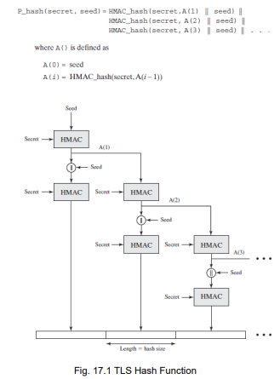

**12.**

**Ppt 69 start,ppt 78 important pic**

**Material 46 ,49main concept**

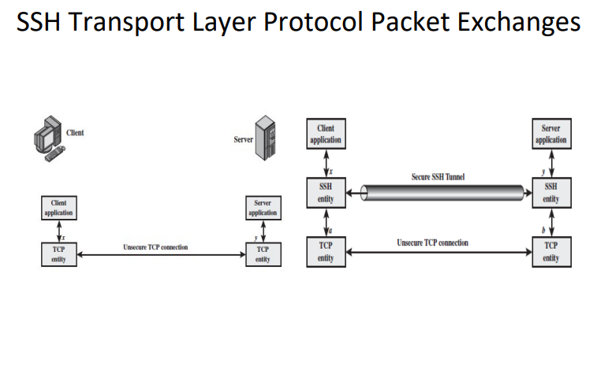

The figure demonstrates the sequence of events in the SSH Transport Layer Protocol: • First, the client establishes a TCP connection to the server. This is done via the TCP protocol and is not part of the Transport Layer Protocol. • Once the connection is established, the client and server exchange data, referred to as packets, in the data field of a TCP segment.

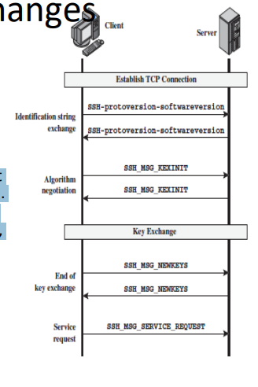

**SSH Transport Layer Protocol Packet Exchanges** • The SSH Transport Layer packet exchange consists of a sequence of steps • The first step, the identification string exchange, begins with the client sending a packet with an identification string. • Next comes algorithm negotiation. Each side sends an SSH_MSG_KEXINIT containing lists of supported algorithms in the order of preference to the sender. There is one list for each type of cryptographic algorithm. The algorithms include key exchange, encryption, MAC algorithm, and compression algorithm. • The next step is key exchange. The specification allows for alternative methods of key exchange, but at present, only two versions of Diffie-Hellman key exchange are specified. • The final step is service request. The client sends an SSH_MSG_ SERVICE_REQUEST packet to request either the User Authentication or the Connection Protocol. Subsequent to this, all data is exchanged as the payload of an SSH Transport Layer packet, protected by encryption and MAC.

**13.**

**Co4 material 34**

ESP (Encapsulating Security Payload) is a protocol within the IPsec (Internet Protocol Security) suite that provides confidentiality, integrity, and optional authentication for the packets of a communication session. The padding field in ESP serves several important purposes:

1. **Block Alignment:**
   * Many encryption algorithms, such as block ciphers, require input data to be a multiple of a specific block size. The padding field helps to ensure that the payload length is a multiple of the block size, allowing these algorithms to operate correctly.
2. **Confidentiality Enhancement:**
   * The addition of padding can help obscure the actual length of the plaintext payload, enhancing the confidentiality of the transmitted data. Without padding, an observer might be able to infer information about the payload length, potentially leaking sensitive information.
3. **Security Against Traffic Analysis:**
   * Padding adds a degree of randomness to the packet size, making it more challenging for an attacker to conduct traffic analysis. Padding makes the length of ESP-protected packets less predictable, which can contribute to a more secure communication channel.
4. **Preventing Information Leakage:**
   * The padding field helps prevent the leakage of information about the length of the original plaintext. Without padding, an attacker might be able to make educated guesses about the content based on variations in packet size.
5. **Ensuring Consistency:**
   * The padding field ensures that the total length of the ESP packet is consistent with the length specified in the ESP header. This helps in maintaining the integrity of the packet structure and ensures that the recipient can correctly interpret the packet.
6. **Compatibility with Cryptographic Algorithms:**
   * Certain cryptographic algorithms, especially block ciphers like AES, require input data to be a specific length or a multiple thereof. Padding ensures that the plaintext payload aligns with these requirements.

The specific padding used in ESP is usually based on the chosen encryption algorithm. ESP allows for different padding schemes, and the choice may be negotiated during the ESP SA (Security Association) establishment. Common padding methods include PKCS#5 padding for block ciphers.

**14.**

IKE (Internet Key Exchange) is a protocol used in IPsec (Internet Protocol Security) to establish security associations (SAs) and exchange cryptographic keys between two parties, typically between a VPN client and a VPN gateway. IKE facilitates secure communication by negotiating the parameters for the encryption and authentication algorithms. The cookie exchange mechanism in IKE is designed to prevent denial-of-service attacks and to handle the cases where the initiating party doesn't receive a response from the responder.

Here's an overview of how cookie exchange is managed by IKE:

1. **Initiator Sends IKE_SA_INIT Request:**
   * The IKE SA (Security Association) initiation begins with the initiator sending an IKE_SA_INIT request to the responder.
2. **Responder Generates and Sends Cookie:**
   * The responder generates a "cookie" value, which is essentially a random value or some hashed information.
   * The responder includes this cookie in its response to the initiator as part of the IKE_SA_INIT response.
3. **Initiator Receives Response with Cookie:**
   * Upon receiving the IKE_SA_INIT response, the initiator processes the response and extracts the cookie sent by the responder.
4. **Initiator Resends IKE_SA_INIT with Cookie:**
   * The initiator sends a new IKE_SA_INIT request, including the received cookie, to the responder.
   * This is essentially a confirmation from the initiator that it received the responder's response and is a legitimate party.
5. **Responder Verifies Cookie:**
   * The responder checks the cookie received from the initiator against its records. If the cookie is valid, the responder proceeds with the IKE negotiation.
   * If the cookie is invalid or missing, the responder may ignore the request or take appropriate action, such as sending a new cookie.

**Purpose of Cookie Exchange in IKE:**

* **Denial-of-Service (DoS) Protection:**
  + The cookie exchange mechanism helps prevent DoS attacks by ensuring that the responder doesn't allocate significant resources until it has received a valid response from the initiator.
  + By exchanging cookies, both parties confirm their ability to receive and process messages.
* **Handling Unacknowledged Requests:**
  + In cases where the initiator sends a request but doesn't receive a response (due to network issues, for example), the use of cookies ensures that the initiator can reinitiate the process with the correct cookie.
* **Stateless Responder Handling:**
  + In some scenarios, the responder may operate in a stateless manner, and the cookie exchange helps maintain the necessary context for security association establishment.

In summary, the cookie exchange in IKE is a crucial part of the initiation process, adding an extra layer of security and robustness to prevent denial-of-service attacks and ensure the successful establishment of security associations between the initiating and responding parties.

**15.** RFC 4308 defines the Cryptographic Suites for IPsec. Specifically, it outlines the cryptographic algorithms and key exchange mechanisms used in the creation of Security Associations (SAs) for the Internet Key Exchange (IKE) protocol. One of the suites defined in RFC 4308 is the "RFC 4308 Cryptographic Suites for IPsec" suite.

The "RFC 4308 Cryptographic Suites for IPsec" is designed to provide a set of algorithms for different security services, including confidentiality, integrity, authentication, and key exchange. It includes various combinations of algorithms to cater to different security requirements.

Here is a detailed explanation of the components of the RFC 4308 Cryptographic Suites:

**1. IKE Phase 1 Transform (Main Mode):**

**a. Authentication:**

* **Description:** Specifies the method used for authenticating the communicating parties during the IKE negotiation.
* **Options:**
  + **Shared Key:** A pre-shared key (PSK) is used for authentication.
  + **RSA Digital Signature:** Public-key certificates are used for authentication.

**b. Encryption:**

* **Description:** Defines the algorithm used for encrypting the IKE negotiation traffic.
* **Options:**
  + **DES-CBC:** Data Encryption Standard (DES) in Cipher Block Chaining (CBC) mode.
  + **3DES-CBC:** Triple DES in CBC mode.
  + **AES-CBC:** Advanced Encryption Standard (AES) in CBC mode.

**c. Pseudo-Random Function (PRF):**

* **Description:** Specifies the PRF used for generating keying material during the IKE negotiation.
* **Options:**
  + **HMAC-SHA-1:** Hashed Message Authentication Code with SHA-1.
  + **HMAC-SHA-256:** Hashed Message Authentication Code with SHA-256.

**d. Diffie-Hellman Group:**

* **Description:** Determines the strength of the key exchange mechanism used during the IKE negotiation.
* **Options:**
  + **Group 1:** 768-bit MODP group.
  + **Group 2:** 1024-bit MODP group.
  + **Group 5:** 1536-bit MODP group.
  + **Group 14:** 2048-bit MODP group.
  + **Group 15:** 3072-bit MODP group.
  + **Group 16:** 4096-bit MODP group.
  + **Group 17:** 6144-bit MODP group.
  + **Group 18:** 8192-bit MODP group.

**2. IKE Phase 2 Transform (Quick Mode):**

**a. Integrity:**

* **Description:** Specifies the algorithm used for ensuring the integrity of the data during the IPsec SA negotiation.
* **Options:**
  + **HMAC-MD5-96:** Hashed Message Authentication Code with MD5 (96 bits).
  + **HMAC-SHA-1-96:** Hashed Message Authentication Code with SHA-1 (96 bits).
  + **AES-XCBC-MAC-96:** AES XCBC-MAC with a 96-bit truncation.

**b. Encryption:**

* **Description:** Defines the algorithm used for encrypting the data during the IPsec SA negotiation.
* **Options:**
  + **NULL:** No encryption.
  + **DES-CBC:** Data Encryption Standard (DES) in Cipher Block Chaining (CBC) mode.
  + **3DES-CBC:** Triple DES in CBC mode.
  + **AES-CBC:** Advanced Encryption Standard (AES) in CBC mode.

**c. Perfect Forward Secrecy (PFS):**

* **Description:** Specifies whether Perfect Forward Secrecy is used and, if so, the Diffie-Hellman group.
* **Options:**
  + **None:** No PFS.
  + **Group 1 to 18:** Same options as in IKE Phase 1.

These cryptographic suites allow for flexibility in configuring IKE negotiations based on the specific security requirements of a given environment. Users can select the appropriate combination of authentication, encryption, integrity, and key exchange mechanisms to achieve the desired level of security for their IPsec connections.

**16.**

SP 800-177, titled "Trustworthy Email," is a guideline published by the National Institute of Standards and Technology (NIST) that provides recommendations for securing email communication. It focuses on ensuring the authenticity and integrity of email messages. The standardized protocols mentioned in SP 800-177 include DKIM (DomainKeys Identified Mail), DMARC (Domain-based Message Authentication, Reporting, and Conformance), and SPF (Sender Policy Framework). Let's develop a model to illustrate their interrelationship:

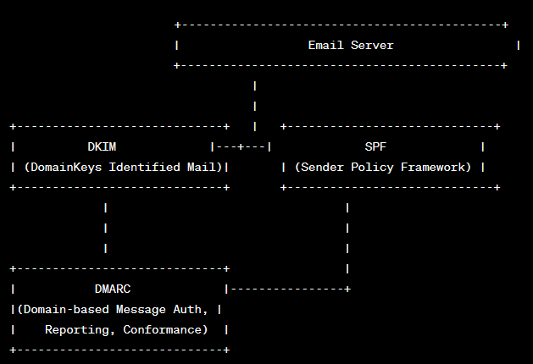

**Interrelationship Explanation:**

1. **DKIM (DomainKeys Identified Mail):**
   * **Purpose:** Provides a mechanism for email senders to digitally sign their messages, allowing the recipient to verify that the message was indeed sent by the claimed sender and that it hasn't been tampered with during transit.
   * **Interrelationship:** DKIM signatures can be included in the email header or body. These signatures serve as a proof of authenticity and integrity.
2. **SPF (Sender Policy Framework):**
   * **Purpose:** Allows the domain owner to specify which mail servers are authorized to send email on behalf of their domain. SPF helps prevent email spoofing and ensures that messages claiming to be from a particular domain are sent from authorized servers.
   * **Interrelationship:** SPF records are published in the DNS (Domain Name System) and provide a policy framework for validating the authenticity of the sending mail server.
3. **DMARC (Domain-based Message Authentication, Reporting, and Conformance):**
   * **Purpose:** Builds on DKIM and SPF to provide a policy framework and reporting mechanism. DMARC allows domain owners to set policies for the treatment of messages that fail authentication checks and enables reporting of authentication results.
   * **Interrelationship:** DMARC relies on DKIM and SPF to authenticate messages. It allows domain owners to specify how receivers should handle messages that don't pass authentication (reject, quarantine, or allow), providing an additional layer of control.

**Workflow:**

1. **Email Transmission:**
   * An email is sent from the sender's domain to the recipient's domain.
2. **DKIM Signing:**
   * The sending mail server signs the email with a DKIM signature, adding a digital signature to the message header or body.
3. **SPF Verification:**
   * The recipient's mail server checks the SPF record in the DNS to verify that the sending server is authorized to send emails on behalf of the sender's domain.
4. **DKIM Verification:**
   * The recipient's mail server verifies the DKIM signature to ensure that the email hasn't been tampered with and is indeed from the claimed sender.
5. **DMARC Evaluation:**
   * DMARC policies set by the sender's domain owner are applied, determining how the recipient's server should handle messages that fail DKIM or SPF checks.

This model illustrates how DKIM, SPF, and DMARC work together to enhance the authenticity and integrity of email messages, providing a comprehensive framework for securing email communication.